Homework #1
EE 4077: Fundamentals of Machine Learning

1 Warm-up [20 points]
- (5 points) Multivariable Calculus: Consider a real function $f(x,z) = xcos(z)e^{-3x+z}$, where $x,z ∈ R$. What is the partial derivative of $f(x,z)$ with respect to $x$?
b. (5 points) Mean and Variance: If the variance of a zero-mean random variable $X$ is σ², what is the variance of 2X? What about the variance of X + 2?

- (5 points) Probability: Consider the following joint distribution between X and Y

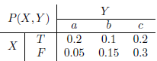

What is $P(X = T|Y = b)$?
- (5 points) Show that the function $f(x) = |x| + e^{x}$ over the domain $x ∈ R$ is convex.

2 Linear algebra [15 points]
- (3 points) The covariance matrix $Σ$ of a random column vector $X$ is defined as $Σ = E[(X -E[X]){(X - E[X])}^{T}]$, where $E[X]$ is the expectation of $X$. Is $Σ$ positive-semidefinite? Why? Recall a matrix is positive semi-definite if for any vector $x, x^{T}Ax ≥ 0$.
- (6 points) Let $A,B ∈ R^{n×n}$ be two symmetric matrices. Suppose $A$ and $B$ have the exact same set of eigenvectors $u_{1},u_{2},··· ,u_{n}$ with the corresponding eigenvalues $α_{1},α_{2},··· ,α_{n}$ for $A$, and $β_{1},β_{2},··· ,β_{n}$ for $B$. Write down the eigenvectors and their corresponding eigenvalues for the following matrices:
  - $C = A + B$
  - $D = A - B$
  - $E = AB$
  - $F = A^{-1}B$ (assume $A$ is invertible)
- (6 points) Let $A ∈ R^{m×n}$, $b ∈ R^{m}$ be given. For a given value of $m$, under what conditions on $A$ and $b$ will the equation $Ax = b$ have
  - no solution?
  - one solution?
  - infinitely many solutions?

3 Vector-valued functions [15 points]
Compute the first and second derivatives of the following functions:

- $f(x) = c^{T}x$, where $x,c ∈ R^{m}$.
- $f(x) = M^{T}Mx$, where $x ∈ R^{m}$ and $M ∈ R^{m×m}$. What happens if $M = M^{T}$?

- Entropy [10 points]
Let $X$be a random variable with the Bernoulli distribution $B(1,p)$, where $0 < p < 1$. The entropy of $X$ is defined as $H(p) = -plog(p) - (1 - p)log(1 - p).$

  - Derive the second derivative $H^{''}(p)$ of $H(p)$. If $H^{''}(p)$ < 0, $H(p)$ is called concave. Is $H(p)$ a concave function of p?
  - Find the value of $p ∈ (0,1)$ that maximizes $H(p).$

- Maximum likelihood estimation (MLE) [25 points]
Suppose that $x ∈ R^{d}$ is a random vector with probability distribution D, i.e., $x ∼ D$. Moreover, assume that $w ∈ R^{d}$ is a parameter vector and let
$y= x^{T}w+ϵ$, where $ϵ\sim N(0,σ^{2})$. (1)
Therefore, $y$ is a linear function of $x$ with Gaussian noise added.
- (5 points) Suppose we take $x$ and $w$ to be fixed and given. We then see that $y|x,w$ is a random variable: it is the sum of the fixed, given constant $x^{T}w$ and the Gaussian random variable $ϵ$. What is the conditional distribution of $y|x,w$?
- (6 points) Assume that we (independently) draw $n$ pairs $(x_{i},y_{i}) ∈{ R}^{d} × R$ from the above model, i.e., we draw $x_{i}$ from $D$ and then, given $x_{i}$ we draw a value for $y_{i}$according to Equation (1). What is the distribution of $(y_{1},...,y_{n})|(x_{1},...,x_{n}),w$?
- (3 points) Write down the log-likelihood function of $(y_{1},...,y_{n})|(x_{1},...,x_{n}),w$, using your results from part (b).

- (6 points) We now wish to solve the MLE problem, i.e., to find the parameter $w$ that maximizes the log-likelihood function you derived in part (c). Suppose that $d = 1$, i.e., that $x$ ∈ $R$ and $w$ ∈ $R$; we can then write$x^{T}w$ as the product $xw$. Derive the optimal parameter $w$ that maximizes the log-likelihood. Hint: The log-likelihood is a concave function of $w$.
- (5 points) Now suppose that $d > 1$. Generalize your result from part (d) to derive the parameter $w$ that maximizes the log-likelihood of the conditional model from part (c).
6 Programming [20 points]
Follow the instructions below and use the programming language of your choice to solve the Lighthouse problem.

6.1 Problem: the lighthouse
(From D. Sivia’s book, “Data Analysis - A Bayesian Tutorial”):
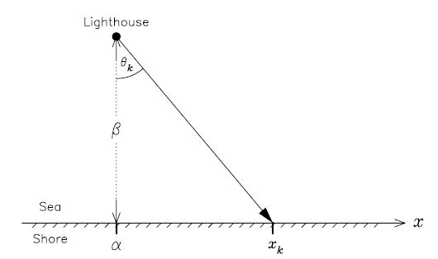
A lighthouse is somewhere off a piece of straight coastline at a position $α$ along the shore and a distance $β$ out at sea. It emits a series of short highly collimated flashes. The flashes are sent out at random azimuths, where the azimuth is chosen uniformly at random between $[0, π].$ These pulses are intercepted on the coast by photodetectors that record only the fact that a flash has occurred, but not the angle from which it came. N flashes have been recorded so far at positions $\{x_{k}\}$. Suppose $β$ is given. Where is the lighthouse?

6.2 Guided solution
We need to estimate the parameter $α$. Let us start by writing the likelihood for this problem; since the flashes are thrown at uniform random azimuths in $[0, π].$, we know that:
$$P\left(θ_{k} | α,β\right)=\frac{1}{π}$$.
Moreover, $β\tan\left(θ_{k}\right)=x_{k}-α$. Since $θ_{k}$ is random variable, $x_{k}$ will also be random variable. Probability density function of $x_{k}$ can be computed from the probability density function of $θ_{k}$ as (check out your probability course lecture notes!)
$$P\left(x_{k} | α,β\right)=\frac{β}{π\left[β^{2}+{(x_{k}-α)}^{2}\right]}$$
The above likelihood is the Cauchy or Lorentz distribution. We will sample from it so that we can have some synthetic data to work with. As an example, the Cauchy distribution for $α=30, β=10$ is shown below for ${-90≤x}_{k}≤90$.
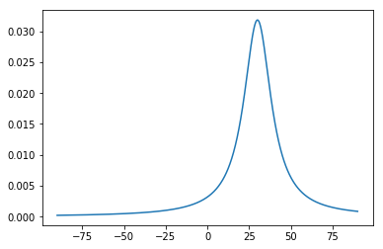

Assuming our prior $P(α)$ is a uniform distribution, posterior probability of $α$ given $\left\{x_{k}\right\},β$ is given by
$$P\left(α | \left\{x_{k}\right\},β\right)∝\prod_{k=1}^{N}{P\left(x_{k} | α,β\right)P(α|β)}∝\prod_{k=1}^{N}{P\left(x_{k} | α,β\right)}$$

To plot the posterior distribution of $α$, weed need to generate ${\{x_{k}\}}_{k=1}^{N}$values from the Cauchy distribution for the given $α,β$. This can be achieved by using a simple trick from the probability theory. The fundamental result you need is that for any random variable $X$ with a cumulative distribution function $F(X)$, the random variable $Y=F(X)$ has a uniform distribution on [0,1]. Consequently, if you can invert $F(X)$, then you can use a uniform density to simulate back your random variable $X$ since $X=F^{-1}(Y).$ In our case, $X$ is a Cauchy random variable with a cumulative distribution function
$$F\left(x\right)=\int_{-∞}^{x}{P_{X}\left(t\right)dt}=\int_{-∞}^{x}{\frac{β}{π\left[β^{2}+{(t-α)}^{2}\right]}}dt=\frac{1}{π}Arctan\left(\frac{x-α}{β}\right)+\frac{1}{2}$$
Therefore, if we let
$$y=\frac{1}{π}Arctan\left(\frac{x-α}{β}\right)+\frac{1}{2}$$
we immediately get
$$x=βtan\left(π\left(y-\frac{1}{2}\right)\right)+α$$
Hence, to realize a Cauchy random variable, generate a uniformly distributed random number in [0,1] (in the programming language of your choice there should be a function to do that. For example, in MATLAB function rand() generates a uniformly distributed number on [0,1]), subtract 1/2 from it, multiply the result by π, and apply the tangent function, multiply the tangent function output by $β$ and add $α$ to the product. Repeating this procedure $N$ times, we can get ${\{x_{k}\}}_{k=1}^{N}$values from the Cauchy distribution. Plot of the posterior distribution for $β=10, N=1000$ is shown below for $0≤α≤60$. We see that the posterior distribution is maximized when $α=30$.
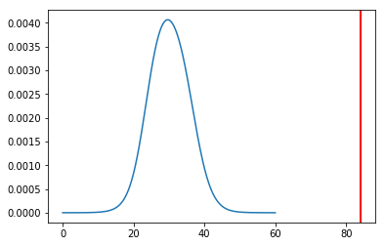

Exercise 1: Suppose $β=10.$ Create 4 posterior distributions of $α$ for different values of $N = 2, 5, 20 ,100$ for $0≤α≤60$. In your plots, note the mean does not coincide with the mode of the posterior! Why is that? Will they coincide in the N → ∞ limit?
Exercise 2: Now, compute the value of $α$ that maximizes the posterior (and the likelihood, since our prior here is uniform). The log-likelihood reads:

$$L\left(α\right)=log\left(P\left(α | \left\{x_{k}\right\},β\right)\right)=log\left(\prod_{k=1}^{N}{P\left(x_{k} | α,β\right)}\right)=\sum_{k=1}^{N}{log\left(P\left(x_{k} | α,β\right)\right)}=-\sum_{k=1}^{N}{\log\left(β^{2}+{\left(x_{k}-α\right)}^{2}\right)}+c$$

where $c$ is a constant. Hence, the maximum is obtained at

$$2\sum_{k=1}^{N}{\frac{x_{k}-α}{β^{2}+{(x_{k}-α)}^{2}}}=0$$.

Now, let’s solve this numerically for different values of $N$. Plot the ML estimate of α for N between 10 and 1000 in increments of 10. You can use an off the shelf function in the programming language you have chosen to find a root of a function on an interval.

